**SQL**

* Find all the information of the customer who lives in Mirpur.

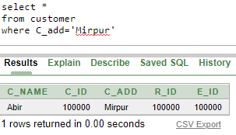

* Find name and salary of the employees who sold fish.

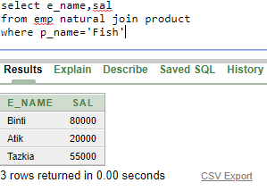

* Find name and id of the employee who gets minimum salary.

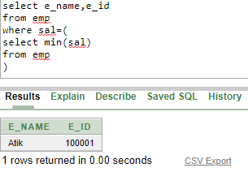

* Create a view customer_info based on customers’ name, id and contact no.

create view customer_info as

select c_name, c_id

from customer

* Create a sequence for customer where customer id is 100006 to 100050 and increases by 1. Then alter the sequence where max id limit is 100090.

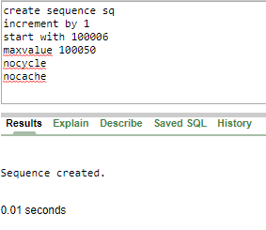

//Alter sequence

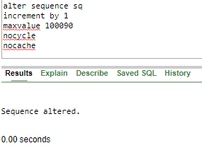

* Display product name, company name and supplier name in one table where Jaman is the supplier.

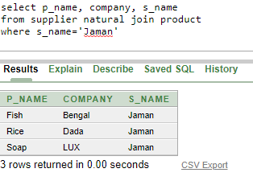

* Display all employee data who served Abir.

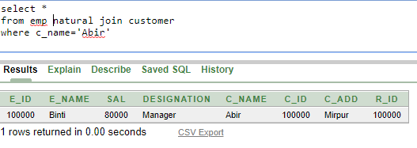

* Display average salary of all the employees.

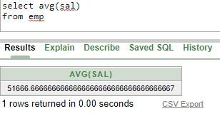

* Rename employee sal to salary.

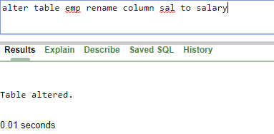

* Display all constraints.

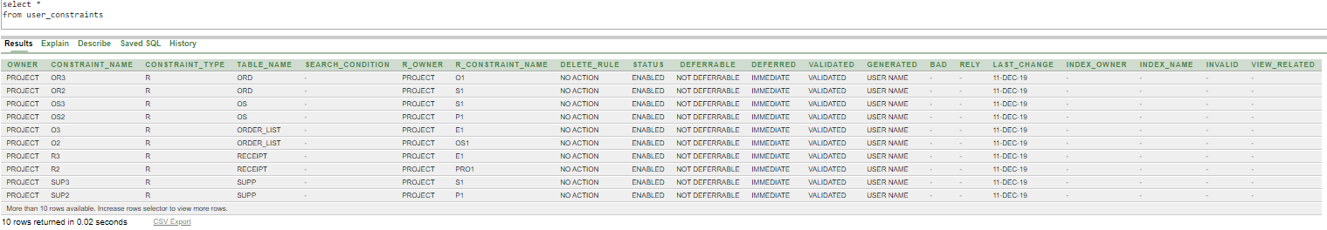

**THE END**